Competitor SEO Analysis Report
Industry: Aroma, Diffusers & Fragrance Products

Executive Summary
We analyzed the provided competitor websites using SEO performance data, including Authority Score, Organic Traffic, Organic Keywords, Referring Domains, and ranking keyword visibility.
The overall competitor landscape shows that most analyzed websites have limited organic search visibility. None of the reviewed competitors are ranking for a large number of valuable keywords, and most websites are generating relatively low monthly organic traffic.

Key Findings
- Most competitors are ranking for fewer than 100 organic keywords.
- The majority of websites receive less than 250 estimated organic visitors per month.
- Several competitors have backlinks but are not converting that authority into strong keyword rankings.

Competitor Performance Overview
Competitor | Observation
Aromatics.com | Good authority and backlinks but very limited organic visibility.
Appellation.co | Low keyword footprint and low traffic.
Crearoma.com.sa | Very weak organic presence.
Aroma360.com | Better authority but still limited keyword coverage.
West-story.com | Traffic exists but authority is comparatively low.
Nota-nota.com | Growing visibility but limited keyword range.
Rezaroma.com | Moderate performance with limited keyword depth.
Nassscent.com | Some keyword presence but weak authority.

Competitor Data Screenshots
Screenshot 1
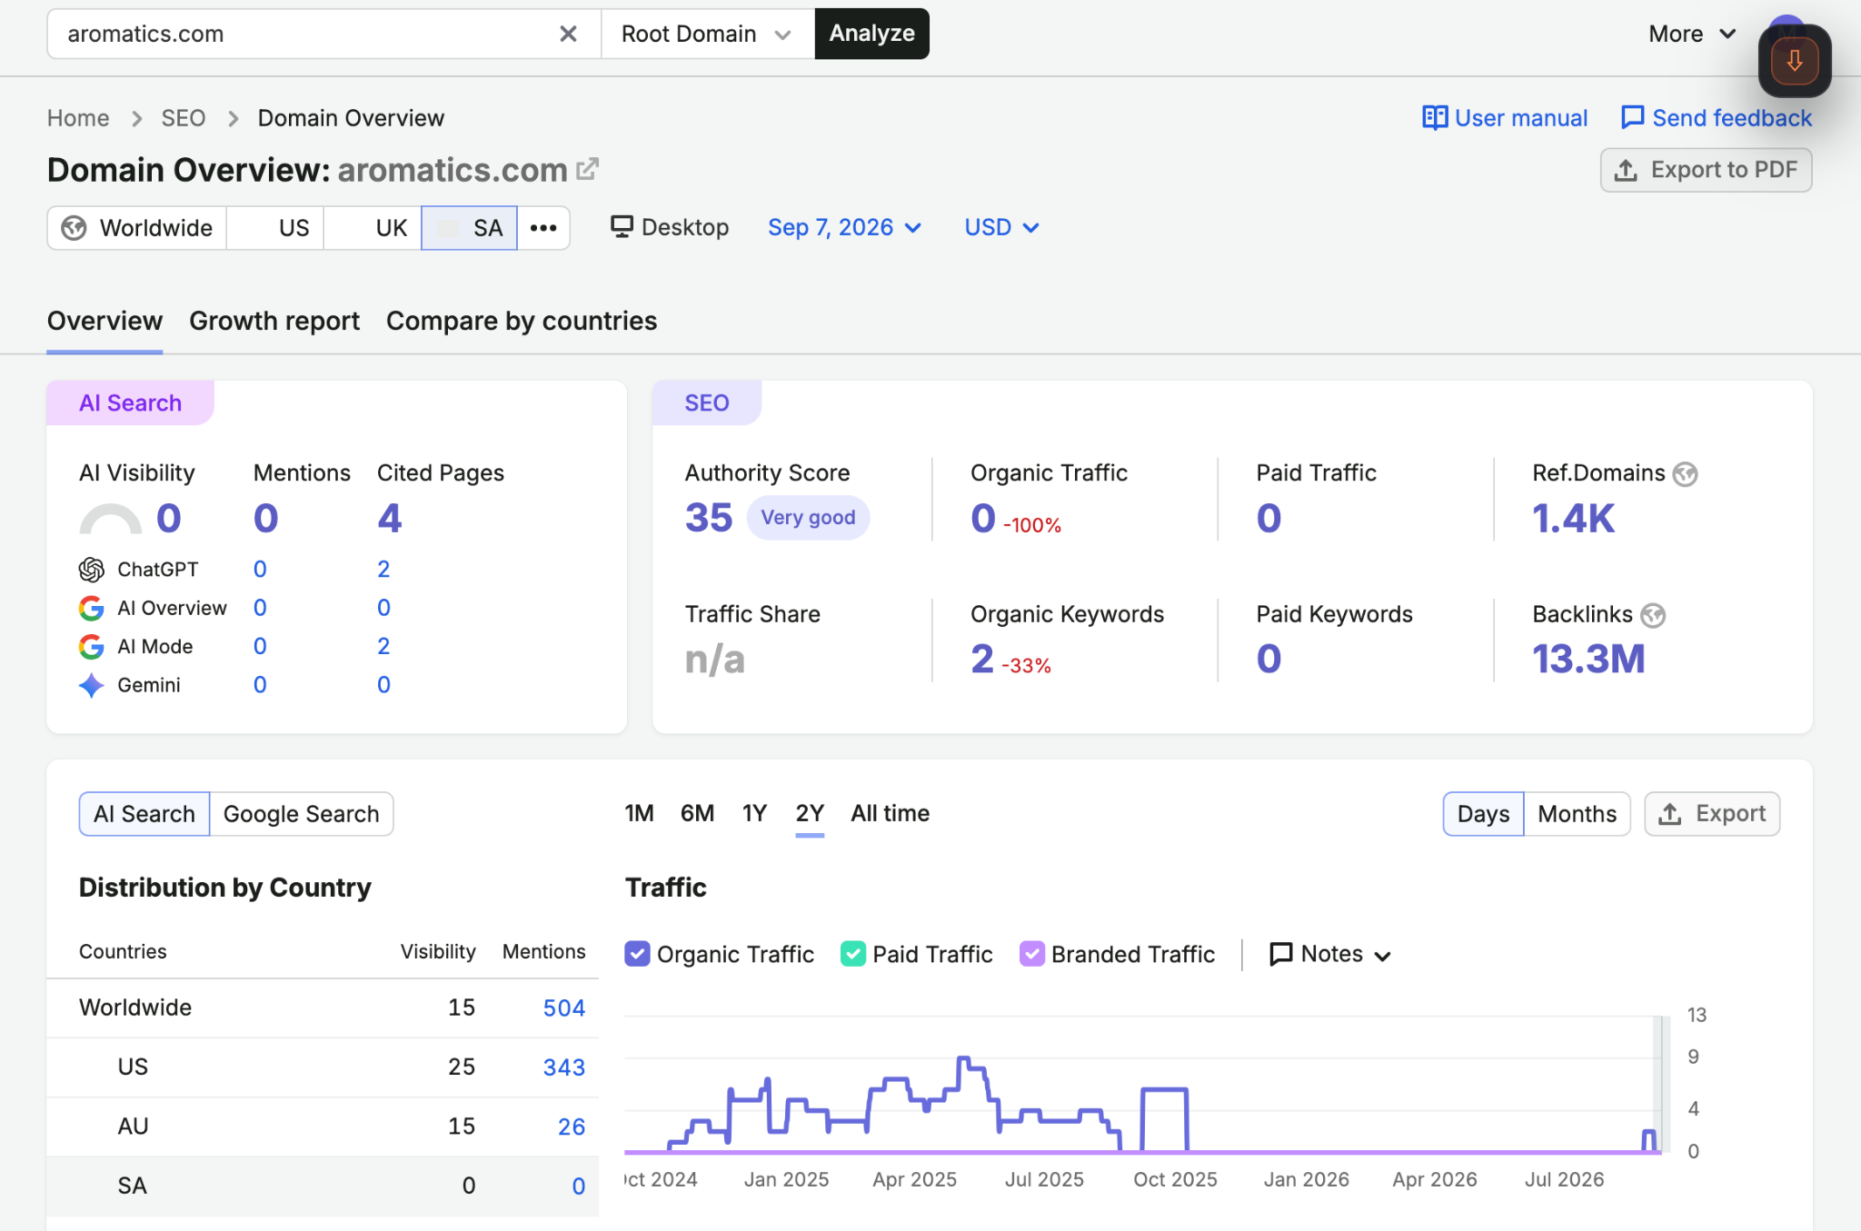
Screenshot 2
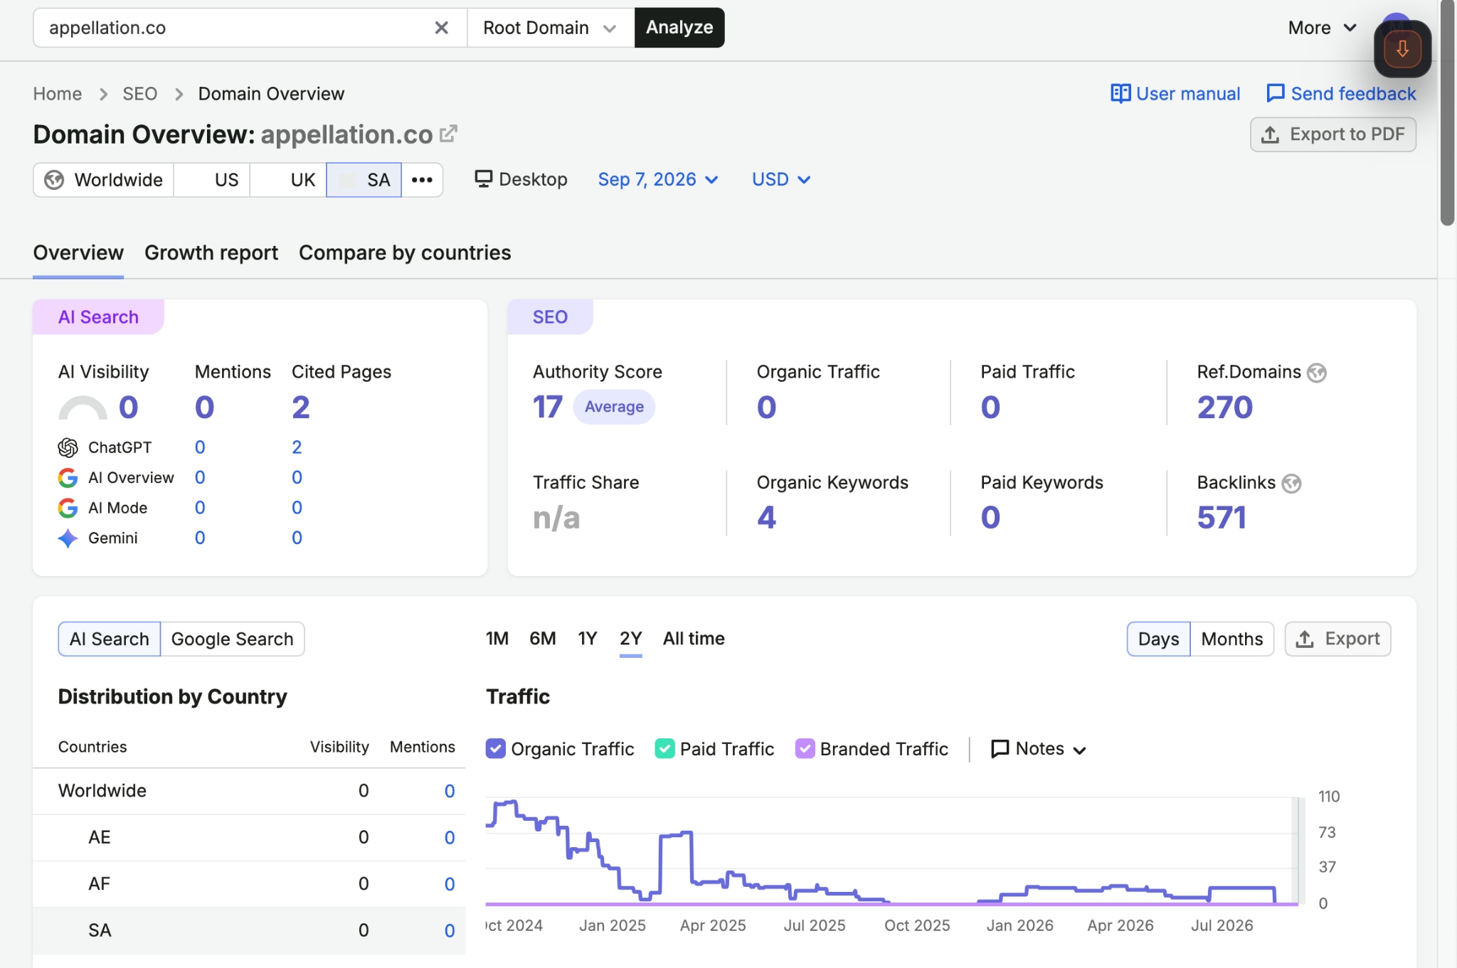
Screenshot 3
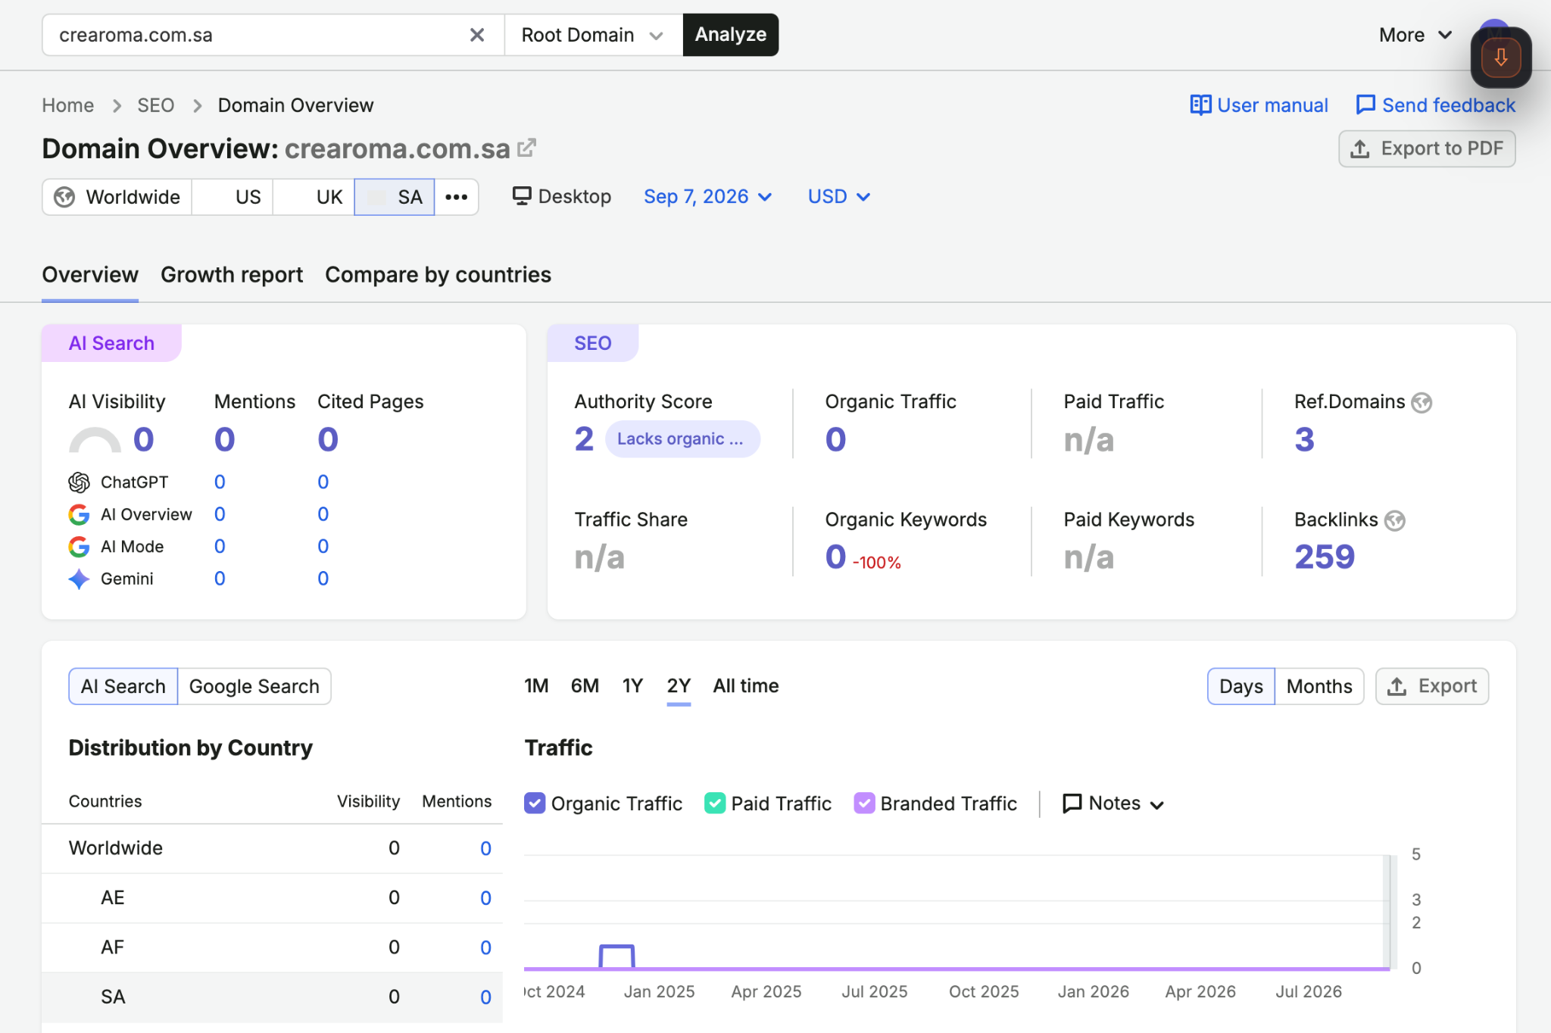
Screenshot 4
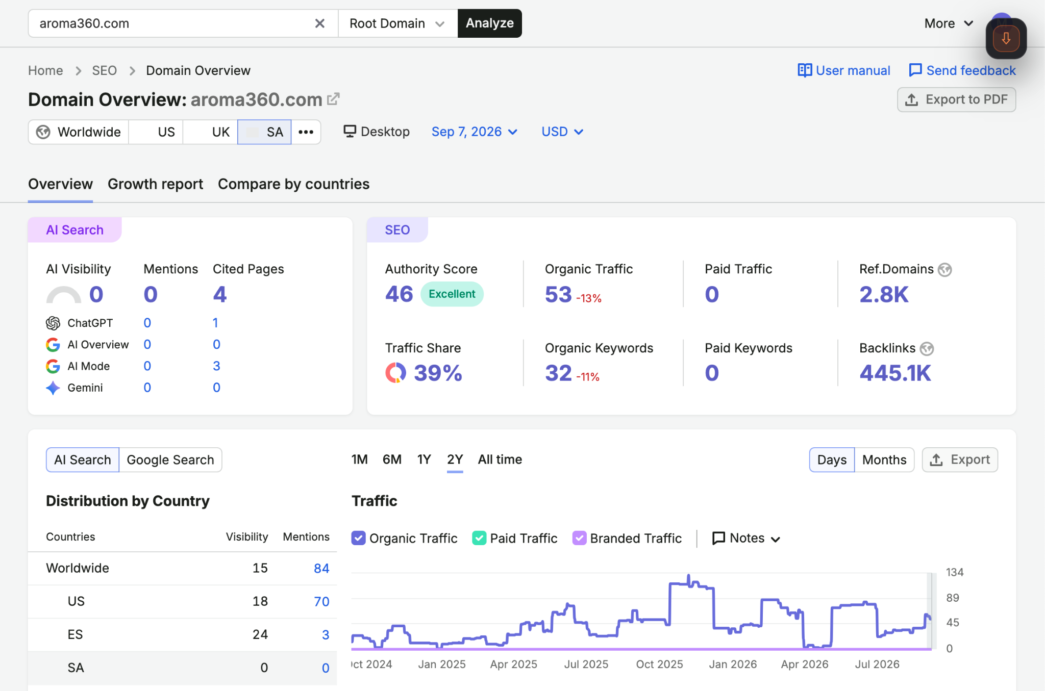
Screenshot 5
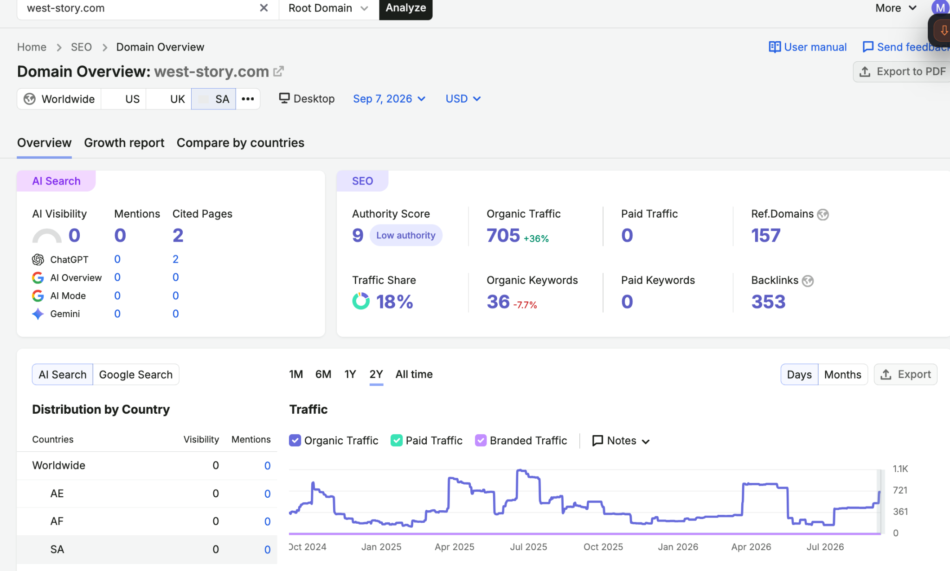
Screenshot 6
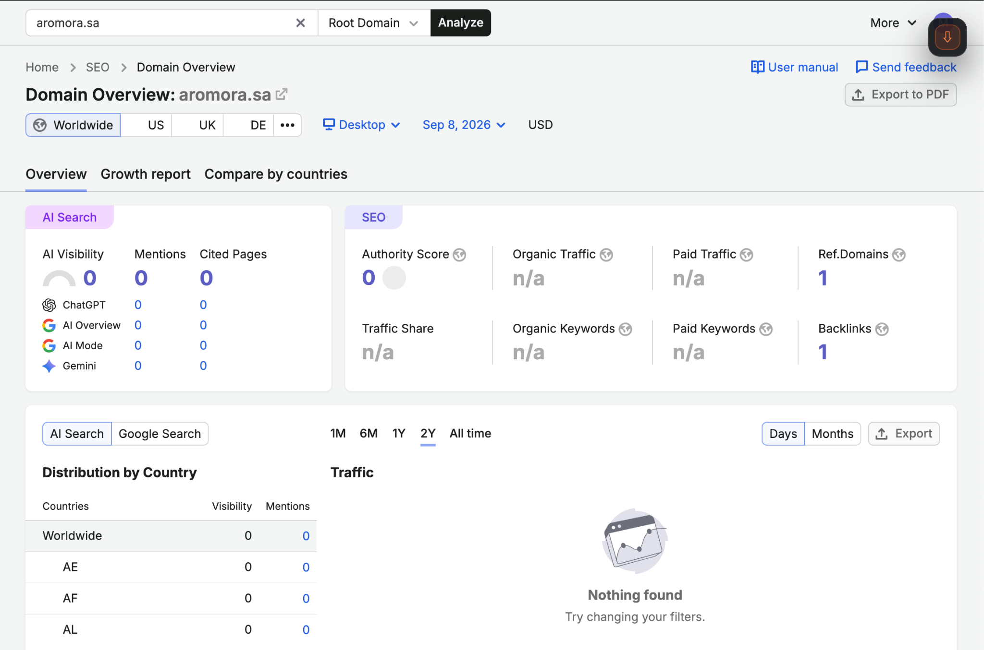
Screenshot 7
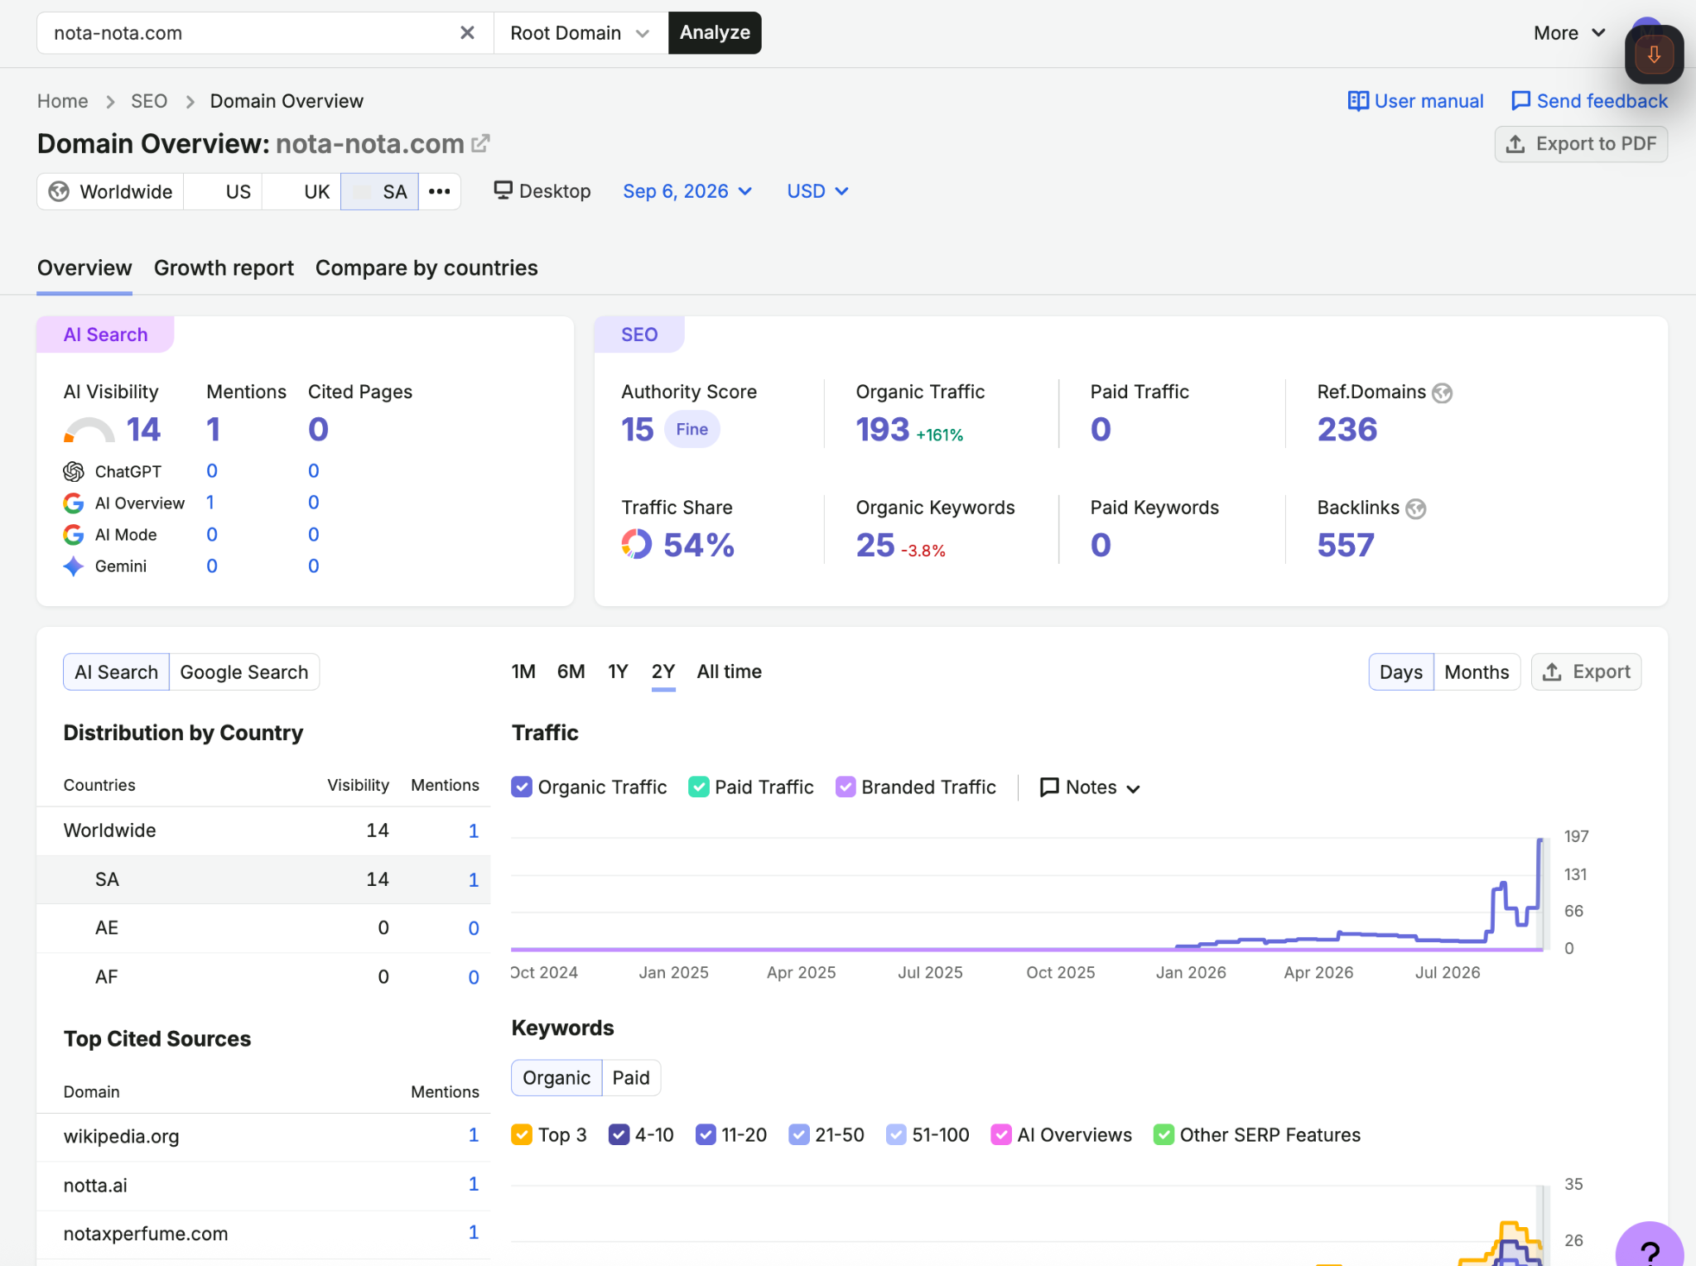
Screenshot 8
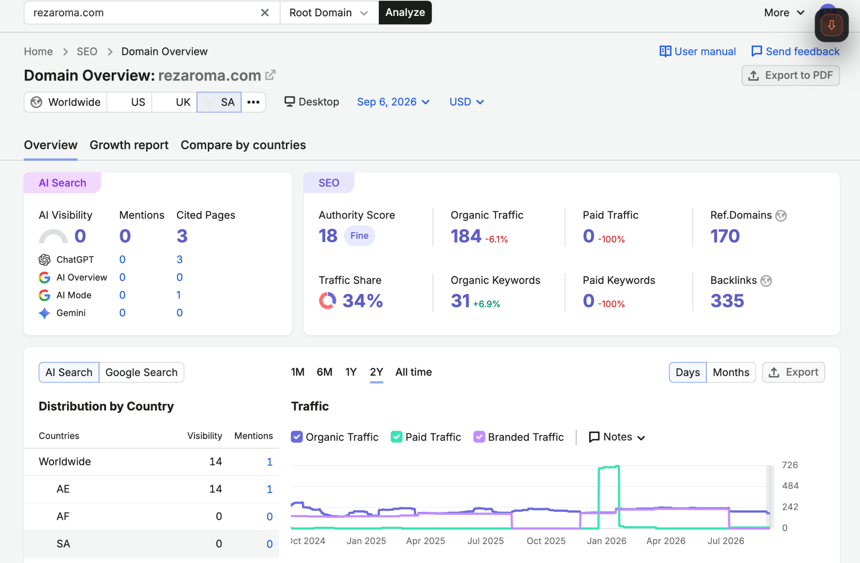
Screenshot 9
